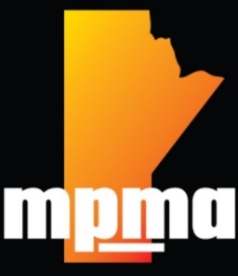

April 18th, 2024

President’s Report – Manitoba Pest Management Association (mpma.ca)

The association in 2023 had its first in person meeting to reestablish the MPMA board in April 2023. The association voted in favour of a new president, secretary and maintained the long time serving member, Debbie Labonte as Treasurer. The association was very quiet for 4 long years also due to the pandemic being a factor for any training and meetings not occurring during those times. As a result, the board set up its first in person meeting and training session for Jan 19th, 2024. The meeting had 29 member companies attend. The agenda is attached. Based on comments after the meeting it was quite well received by the attendees and we will be setting a fall meeting or a winter meeting as the year progresses.

Overall, in 2023 there were 16 company members and the invitation was sent out to non-member companies to introduce them to our association and the benefits of being a member. I wish to thank Suzy Rayner and Kathy Cano for assisting in making this meeting happen. I also wish to thank Debbie Labonte for being our treasurer since the associations inception 9 years ago..

Its was great to have the association up and running again and I will make sure it continues.

Respectfully submitted,

Taz Stuart, M.Sc., P. Biol.

President, MPMA